Debate on Dasam Granth; Issues and Evidence.

In my opinion one must understand varios aspects of issues involved in Dasam Granth Debate.

A)No body should Challenge "Amrit Sanchar/Creation of Khalsa/ Five Kakkars/Khande the Pahul or Sikh Baptism as some people call it because “There is historical proof in all Sikh, Persian& europian/English sources about this event and Sikh symbols which actually happened in 1699”.

Academic issue is that what Banis were recited during Amrit sanchar.
Review of sikh literature prior to 1900 C.E. shows that there is no mention about the recitation of the five ‘banis’ which are recited these days while preparing ‘amrit’..’ It varied from group to group, and ‘dera’ to ‘dera’ (seminary).Kirpal singh has summarized this literature review as follows.

(1) Rehatnama Bhai Daya Singh (Piara): A good Sikh partakes of ‘amrit’ of Sri Amritsar. First, he reads or recites complete Jap ji, from the beginning to the end and the Chaupai. Which Chaupai (quartet)? (There is no indication.) He reads five different sawaiyas: 1. Srawag 2.Dinan Ki Pritpal 3. Papp smooh Binasan 4. Sat sdaiv suda brat, and 5 five stanzas of Anand Sahib. He stirs the ‘armit’ with a kirpan towards himself. Then one Singh places a kirpan beside him. (Note: Here there is no mention of Jaap Sahib and complete Anand Sahib. There is however mention of stirring ‘amrit’ with a Kirpan.)

(2) Bhai Chaupa Singh (Tenth Gurus’s Hazuri Sikh): Then the perfect Guru Sahib started testing the Panth. On the seventh day of Sawan, 1756 Sambat, the consecrated drink was sought to be prepared. Guru Sahib said, “Chaupa Singh, bring water in a bowl.” When water was brought, Guru Sahib commanded, “Hold the ‘Khanda’ (double edged sword) and stir the contents of the bowl.” Then all the five started reading out ‘swaiyas’ each. Which five? Daya Singh…. Sahib Singh…. Himmat Singh…. Dharam Singh…. Mohkam Singh…?. When these five Singhs started reading out ‘swaiyas’, then Sahib Chand Diwan made a request, “True Sovereign, if ‘ptashas’ (sugar bubbles) are put in the bowl, it will be better.” In the meanwhile, Mata Shakti, Mata Sahib kaur, assuming the form of the ‘devi’ (goddess) put sugar bubbles in the bowl. The perfect Guru Sahib took five palmfuls and put them on the eyes, and five palmfuls in the hair. Then he recited the following ‘swaiya’ from the ‘Chandi Charitar’:
“Deh Shiva war mohey ehay
Shubh karman te kabhon na taron.
Na daron ar siyon jab jaye laron nishchay kar apni jeet karon.
Ar Sikh hon apne hi mann ko eh lalach han gun ton ochron.
Jab aav ki audh nidhan baney
At hi run mein tab joojh maron.
[O God of power, bless me,
That nothing deters me from gracious deeds.
And when fight I must, I fight for sure to win.
That I am instructed in wisdom only by my higher mind,
That I crave ever to utter thy praise.
When comes the end of my life,
I die fighting in the thick of a (righteous) war’}

Guru Sahib administered ‘amrit’ to the five Singh with his own hands. Next day, more Sikhs requested the Master that they too be administered ‘amrit’. He said, ‘prepare ‘Karah Parshad’ and have it from the five Singhs after reading ‘swaiyas’.
[Note: This ‘Maryada’ (practice) too does not accord with any current practice or any other practice.]

(3) According to Guru Bilas Patshahi Daswin: [Author: Bhai Koer Singh, p-128] It is considered to have been written in 1808 sambat, i.e. 1751 A.D. about 43 years after the passing away of the Tenth Guru]

‘Sarita jal leen achhoot mangaye kay,
Patar loh mein tan prabh beray.
Parhtey su udass hai mantron ko,
Prabh thadhey hai app bhaiye so saverey.’ (p-25)
[Note: Here there is only a mention of reading ‘mantra’ (mool mantra)]

(4) B a n s a w a l i n a m a: [Genealogical Tree] of the ten Guru Sahibaan written by Bhai Kesar Singh Chhiber (11826 Sambat). According to this writing:
Guru Sahib said: ‘Get a bowl of water at once.’
When it was brought, Guru Sahib gave ‘karad’ (knife) to a Sikh and asked him to stir the water in the bowl. Then Guru Sahib asked him to read aloud Japu Ji Sahib and Anand (Tenth part).

Here it is worth nothing that Chhiber has used the word ‘karad’ instead of Khanda and has mentioned the reading out of two ‘banis’ ‘Jap’ and ‘Anand’.
[Sikh Sanskar atey maryada-Chief Khalsa Diwan, p-63]

(5) History of the Sikhs, written by Khushwant Rai: 1811 sambat, i.e. 1754 A.D. In the peperation of ‘amrit’ there is mention of reading aloud only five swaiyas. (p-63).
Singh Bhangu, edited by Bhai Vir Singh Ji, published in 1941 A.D. Var Bhagauti, first pauri (stanza) swaiya No. 32, Tribhangi Chhand-Khag Khand.
[Note: Here there is mention of reading of reciting three different ‘banis’, which are different from those that are read these days.]
Banis read at the time of preparing ‘amrit’ are: Jap Ji, Swaiyas, five stanzas of Anand Sahib. [Note: Here is no mention of reading out Jaap Sahib and Chaupai. Only reading out five ‘pauris’ (stanzas) of Anand Sahib have been mentioned.]

(8) Guru Panth Parkash: {Giani Gian Singh), edited by: Singh Sahib Giani Kirpal Singh, p-1573}: ‘Jap Ji Sahib-5pauris, Jaap Sahib-5 pauris, Das Sudh, Anand Sahib, and Chaupai.
[Note: Here is mention of reading out five ‘pauris’ each of Jap Ji Sahib and Jaap Sahib and this too is not clear which ‘Chaupai’ should be read out-the one in the beginning of ‘Akal Ustat’ “Pranvo aad ek nirankara” or the 27-pad kabiyo vach Chaupai from 377 ti 404 Chaupadas of Charitar No. 405 of ‘Charitro Pakhiyan’?]

(9) ‘Gurbilas Patshahi 10’: written by Bhai Sukha Singh of Patna Sahib: The author has mentioned the reading out of some ‘mantras’ while preparing ‘amrit’. He has not mentioned the reading out of any particular ‘bani’ or ‘banis’.

(10) ‘Guru Sobha; Likhari, Kavi Senapati (Singh): Guru Gobind Singh’s poet Laureate Senapati (Singh) in his book ‘Guru Sobha’ has not described any method of administering the ‘pahul of Khanda’ (consecrated drink prepared with Khanda-two edged sword). He has only mentioned the ‘kurehats’ (breach of Sikh code of conduct) like mundan (tonsuring), smoking hookah and having relations with ‘minas’ or ‘masands’.

(11) Sri Kalgidhar Chamatkar, written by Bhai Vir Singh: Bhai Vir Singh Ji writes the following on page 27-28: “At the place where yesterday Sikhi was put to test, today there is a throne around which the devotees are sitting. ‘Karah Parsad’ (sweet pudding) for 1100 is kept on white sheets. On the throne is sitting Guru Gobind Singh Ji apparelled in white. Before him lies a shining steel bowl containing water with a two-edged sword in it. In front of him are standing the five Sikhs of yesterday, the liberated ones, who had offered their heads. They too are clad in white. Guru Sahib spoke to them-the five-“ ‘Waheguru’ is the ‘gurmantra’ chant it with perfect concentration.” While the ‘Five’ got busy in chanting ‘Waheguru’, Guru Sahib himself started stirring the ‘Khanda’ in the bowl and reciting ‘banis’. Standing before the ‘Five’ who had offered their heads, he made one of them recite the ‘mool mantra’ five times. Then he gave him five palmfuls of ‘amrit’ sprinkled it on his eyes and put five palmfuls in his hair. In this manner he administered ‘amrit’ to the ‘Five.’

As outlined above review of litraure produced before 1900 A.D.shows lot of Variations on this issue". Therefore this was the Gigantic task before Sikh Leadership in early 1900 Sikh to settle this Panthic issue. They then only followed what 10th guru gave the Final message which is accepted by scholars &sikh Panth that "Guru granth is the spiritual guru onwards from oct 1708 A.D. & Five khalsa( Concept of Panj Pardhangi) as physical Guru. IF there is any issue for the Panth,then it can be decided by consesus of Khalsa Panth based on bani/shabad in Guru Granth Sahib. Bani of G.G.S. is the sole Guru for Sikhs and a sole canon to accept any idea, concept, suggestion, and any writing." GURU PANTH based upon above concept accepted writings of 10th Guru in Sikh Rahat Maryada which were Sanctfied By Guru Panth (1927-1936). Therefore such compostions as accepted by the Panth are final and unquestionable and can not be challeged by anybody. Japu Sahib, 10 swaeyas(swarg Sudu Waley 21-30 akal ustit)and kabio Benti Chaupai upto end of hymn' Dust dokh tay loh Bachai" as writings of 10th Guru (as sanctioned RehatMaryada). Oral history is also very important.In my opinion there are some compositions of 10th master what nobody is sure hundred percent because of lack of evidence in written literature but Panth settled this issue.

There fore in summary Compostions of 10th guru as accepted by the Panth(per SRM) are final and unquestionable and can not be challeged by anybody. Japu Sahib, 10 swaeyas(swarg Sudu Waley 21-30 akal ustit)and kabio Benti Chaupai upto end of hymn' Dust dokh tay loh Bachai" as writings of 10th Guru (as sanctioned RehatMaryada). This was the Gigantic task before Sikh Leadership in early 1900 A.D. They decided whatever they found best based on oral evidence and whatever written sources available to them at that time and setteled the issue once for all.

B)Sikhs have only one Granth (AGGS). Guru Gobind Singh Sanctified only One Granth Which is AGGS only. This historical fact is well documented in Sikh sources of 18th century. Sainapat (1711), Bhai Nandlal, Bhai Prahlad, and Chaupa Singh, Koer Singh (1751), Kesar Singh Chibbar (1769), Mahima Prakash (1775), Munshi Sant Singh on account of Bedi family of the Una, Unpublished records, Bhatt Vahis. Persian sources: Mirza Muhammed (1705-1719 AD), Sayad Muhammed Qasim (1722 AD), Hussain Lahauri (1731), Royal Court News of Mughals, Akhbarat-i-Darbar-i-Mualla (1708). Western accounts of 18th century including Father Wendel, Charles Wilkins, Crauford, James Browne, George Forester, and John Griffith clearly emphasize the tenants of Nanak as enshrined in Guru Granth Sahib as the only promulgated scripture of the Sikh.

Judge Mewa Singh further interprets this issue as follows;
Sikh Gurus rejected all the scriptures of Hinduism and said that
they do not preach or reach the reality of God. Guru Nanak, founder of Sikhism proclaimed-
"Vedas speak of and interpret God but know not his limit; Six are
the creeds of Shastras but no one merges in God through them" {GGS
148}, And,
"Eighteen Purans and four Vedas do not know God's secrets" {GGS
355}, And,
"Shastras and Vedas keep man bound to three modes of materialism,
and he does the blind deeds" {GGS 1126}.
Guru Amar Das, the third Sikh Guru rejected the religious scriptures
of Hindus remarking
"Hindus recite Simirties, Shastras and Vedas but deluded by doubt
they understand not the truth and reality; without following the
divine thought of Gurbani, man understands not reality and obtains
no peace, misery after misery he earns."{GGS 113}
Guru Arjan Dev, 5th Sikh Guru rejected the Hindu Scriptures
"There are many Samirites and Shastras which I have thoroughly
studied; but none of them reaches or preaches the invaluable name of
God" {Sukhmani Sahib}
Guru Gobind Singh, 10th Sikh guru, rejected all the Hindu Gods and
their incarnations and the religious scriptures-
"Ram, Rahim, Puran and Quran have put several thoughts but I accept
none of them; Samirities, Shastras and Vedas describe several
secrets but I recognize none of them" {Sawayas}
Thus,these divine proclamations of Sikh Gurus obviously establish that
they had no belief in Hinduism and that their religion is
independent of Hinduism. Sikh Gurus had out rightly rejected the
Hindu Gods and their incarnations, the Hindu religious scriptures,
the Hindu rites and rituals, and the Hindu caste and creed system.
Sikh Gurus rather presented their independent and separate
universally revealed religion for the entire mankind of the present
age, which satisfies the developed scientific and juristic mind of
today

2)SRM and 1925 Sikh Gurudwara Act clearly accepts and Recommends only SGGS as the only Granth of the Sikhs

The following evidence is clear that Guru Panth (1927-1936) never used the Published Dasam Granth as source of 10th guru Bani while creating Panthic Reht Maryada Document as Dasam granth published since 1902 was available to them.(this printed version is reported to be compiled at Sri Akal takhat sahib and edited by Sodhak committee1n 1895-1897based on various 32 dasam granths available at that time)?

1)Sikh Rehat Maryda sanctified by Guru Panth recommends reading of "Benti chaupai only upto end of hymn' Dust dokh tay loh Bachai" (401)." Why they left 402,403,Aril,404 and 405 hymns as present in Published dasam Granth &various hand written manuscripts?

2)Why they recommended only 10 swaeyas(swarg Sudu Waley 21-30 from akal ustit only and not its total composition of Akal Ustit)?

3) Why there is no mention of Dasam Granth in the sikh rehat maryada( by Guru Panth in 1927-1936)?
4) 1925 Gurudwara act only recommends sikh institutions to follow only Guru Granth Sahib Ji.

Additional Historical Facts

a)The Gurmat Granth Pracharak Sabha and its members which formed sodhak committe who compiled this So called Dasam granth fell into Oblivion after submitting their report. Evidence shows sikhs did not accept this document.

b)Lahore Singh Sabha With 118 associations DID NOT Recognize this newly Dasam Pathshai Guru Granth Sahib finaly compiled by sodhak committe.
c)3 articles published in Khalsa Akhbar Lahore against this committee on october 4th,25th&november1st 1895.
D)Above version of dasam Granth was published first time in 1902 has no significance among the Sikhs as mentioned by Akali Ran Singh in his book(1905) about Dasam Granth.

E)Kahan Singh Nabha in 1930 in Mahan Kosh does not mention 1897 sodhak Committee report or dasam granth published in 1902 based on this report. He talks about only two birs of Mani Singh & Sukha Singh Bir& requests more thorough work on this issue. Sikh scholars since then has reviewed these two birs mentioned has found many authenticity Problems.

From above evidence it is very clear that Guru Panth in (1927-1936) did not use this Document of so called Dasam Granth while making their final decision.

c) Authenticity of presently published Dasm Granth printed version since 1902( based on Sodhak committee report 1895-1897 fro 32 Dasm granth available at that time).

The presently published Dasm Granth since 1902 or other Dasm granth Birs have many questions of authenticity.
followining academic parameters are essentials to prove the authenticity of any Document.
a) Date of Document (When it was Written):
b) History of the Document:
c) Who is the Scribe
d) Internal Inconsistency
Following academic questions from A-H are noted as follows
A)Irregular accounts not supporting Sikh History & Philosophy in Bachtar Natak

• -Bachittar Natak does not mention martyrdom of fifth guru &Adi granth instalation 1604. Four lines between the name of fifth guru and ninth guru. Praise of Guru Teg Bahadur martyrdom in Brahamnical way.
• -Absesnce of Pir Budhu Shah role in Battle of Bhangani.
• -Talks about Bedis and Sodhis but does not mention second guru who was Tehan and third guru who was Bhalla.
• -Places Mohammed appearance in history after Ramanand (wrong chronology)
• -In Canto 7, writes that Guru Gobind Singh went from Patna to madura Des,area between Beas & Jehlum (Bakala?) where he was brought up.
•
• -Does not mention the creation of Khalsa, the most important historical event by Guru Gobind Singh and fails to mention Amrit ceremony.
•
• -Fails to mention Battle of Chamkaur
• -Talks about Waheguru, Akal Purkh but no mention of Adi Granth from 1604 revered by the Sikh Gurus.

B) In one entry in dasam Granth there is Appreciation of King Jahangir as a very merciful king

C) why at many places in Dasam Granth the scribe is ANTI LONG Hair if dasam Granth Suppots Sikh Philosphy
-Befriend him with your words and bring him; or else drag him by the hair to me
-Grab by the hair, and throw him into the middle of the searing, burning mass of coals and wood, Grab the ruler by the hair and strike with full force against the ground
-Having clutched all of the hair, strike him on the ground forcefully. Ensue the battle in this manner.
-She takes the demons by their long hair and slays them with her sword (kirpan)
D) Which is the Authentic Bir written by 10th Guru Ji? Which hand written manusript ( as noted in literatureure) of the So called Dasam Granth was written by 10th master? All of following dasam granth Birs mentioned in literature does not meet authenticity criteria by academic parameters.
-Mani Singh Bir,
-babadeep singh bir,
-Misal Patna Bir
-Two DG birs now present in patna Sahib,
-Moti Bag BirSangrur Bir,
-Ananadpuri(Hazuri) Bir
-VARIOuS hand written MAUSCRIPTS LYING IN British LIBRARY London and HAZUR SAHIB

E)Presently Published Dasam Granth which came in print since 1902 based on Sodhak Committee Report (1895-1897)after looking into 32 dasam granth Birs.

Credentials of various members of this committee. (They were not scholars but Brutish cronies selected by Gurmat Granth Pracharak Sabha controlled by Vihiria Faction amrtsar singh sabha group.They were not selcted by SIKH PANTH because Lahore Singh Sabha With 118 were opposed to it and never recognised this Granth.EVEN SRM and 1925 Gurudwara act did not accpted this Granth.

- Members of Sodhak Committee
- Mana Singh Hakim, known for correct recitation
- Bhai Narain Singh, Teacher
- Bhai Thakar Singh, Clerk Municipal Committee
- Bhai Hajura Singh, Secretary Lakar Mandi
- Dharam Singh, Famous for Chhabil Sewa
- Bhai Sant Singh, Gurmukhi Teacher
- Bhai Darbara Singh with education of Giani
- Jaidial Singh, Middle pass
- Gurdial Singh, Gurmukh Person
- Kishan Singh Ji, Rice Dealer
- Naran Singh, Thakur Singh Rice Dealer,
Makhan Singh Sweet Maker

F) Who gave right to Sodhak committee members to delete any Composition of 10th Guru Sahib?. The following compositions were deleted by the sodhak committee which were present in many manuscripts. Question is why sodhak Committee deleted following Compositions present in so many earliear 32 Dasam granth hand written & published manusripts examined by Sodhak committee (1895-1897).
1. Sansahar Sukhmana – 43 stanzas Few praising Hindu Deities and betraying Sukhmani by 5th Guru
2. Vaar Malkauns – 11 pauris, Nanak Jo Prabh Bhawangey, Harji Harmandar Awangey
3.
Vaar Bhagouti Ji Ki – Different from Vaar Durga Ki – Bhagat Bhagouti Tis Ki, Jo Jan Dhir Dhre
Piara Singh Padam, in his book, clearly documents the following three compositions from the Dasam Granth were taken off.
Other compositions excluded:
4- Sri Bhagwant Gita Bhakha sri Govind singh Kirt
5- Raag Asa &Raag Sorith Patshai Das
6- Asfotak Kabits (Published by Randir Singh in Dasam Granth at Punjabi University)
7-Majh Patshahi 10,
8-chhaka Bhagauti Ji Ka.

G) No re-examinations and reviews took place in 1931, under the ageis of the Darbar Sahib Committee of the Shiromani Gurdwara Prabhandak Committee. This is pure misrepresentation. There is need for needs Factual evidence. Who were the committee members? where is the published report?

H) Internanal Consistancy IssuesThe Text table From Dr.Jaggi,s Book shown different Birs clearly shows that there are many variations in the Title arrangements,Some compositions are missing in some BIrs and there is CHHAND COUNT VARIATIONS In DIfferent BIRS(especially in CharitroPakhyan &Krishan avtar grossly). This clearly shows that this Granth Is is not Fixed but Evolutionary. I am hereby producing those charts from Jaggi,s Book in English so that English reading forum Members can review it and make their opinion on the issue.

TEXTUAL ANALYSIS OF DIFFERENT DASAM GRANTH BIRS
 | MANI SINGH BIR | MOTI BAGH BIR | SANGRUR BIR | PATNA BIR
1 | Japu | Japu | Japu | Japu
2 | Bachittar Natak | Bachittar Natak | Sastar Naam Maala | Akaal Ustit
3 | Chandi Charitar | Chandi Charitar | Akaal Ustit | Swayae 32
4 | Chandi Charitar | Chandi Charitar | Bachittar Natak | Bachittar Natak
5 | Chaubees Avtaar | Chaubees Avtaar | Chandi Charitar | Chaubees Avtaar
6 | Brahmavtaar | Brahmavtaar | Chaubees Avtaar | Chandi Charitar
7 | Rudravtaar | Rudravtaar | Brahmavtaar | Brahmavtaar
8 | Paarasnaath | Paarasnaath | Rudravtaar | Gian Prabodh
9 | Sastar Naam Maala | Sast Naam Maala | Gian Prabodh | Chandi Charitar
10 | Gian Prabodh | Akaal Ustit | Charitropakhia | Rudravtaar
11 | Akaal Ustit | Gian Prabodh | Sansahar Sukhmana | Bisanpadhe
12 | Vaar Durga Ki | Vaar Durga Ki | Vaar Malkauns | Chakka Bhagoti Ji
13 | Charitropakhian | Charitropakhian | Chakka Bhagoti Ji | Sastar Naam Maala
14 | Zafarnaama (Persian) | Asfotak Kabit | Bisanpadhe | Vaar Durga Ki
15 | Sadd | Swayae 33 | Zafarnaama (Gurmukhi) | Charitropakhia
16 | -- | Bisanpadhe | Zafarnaama (Persian) | Asfotak Kabit
17 | -- | Sadd | Swayae 33 | Bhagvat Gita
18 | -- | Zafarnaama  (Gurmukhi) | Asfotak Kabit | Sansahar Sukhmana
19 | -- | Zafarnaama (Persian) | Chhand Without Title | Chhand Without Title
20 | -- | -- | -- | Vaar Malkauns
21 | -- | -- | -- | Vaar Bhagoti
22 | -- | -- | -- | Zafarnaama

 | MANI SINGH BIR | MOTI BAGH BIR | SANGRUR BIR | PATNA BIR
1 | Japu | Japu | Japu | Japu
2 | Bachittar Natak | Bachittar Natak | Sastar Naam Maala | Akaal Ustit
3 | Chandi Charitar | Chandi Charitar | Akaal Ustit | Swayae 32
4 | Chandi Charitar | Chandi Charitar | Bachittar Natak | Bachittar Natak
5 | Chaubees Avtaar | Chaubees Avtaar | Chandi Charitar | Chaubees Avtaar
6 | Brahmavtaar | Brahmavtaar | Chaubees Avtaar | Chandi Charitar
7 | Rudravtaar | Rudravtaar | Brahmavtaar | Brahmavtaar
8 | Paarasnaath | Paarasnaath | Rudravtaar | Gian Prabodh
9 | Sastar Naam Maala | Sast Naam Maala | Gian Prabodh | Chandi Charitar
10 | Gian Prabodh | Akaal Ustit | Charitropakhia | Rudravtaar

 | Mani Singh Bir | Moti Bagh Bir | Sangrur Bir | Patna Bir
11 | Akaal Ustit | Gian Prabodh | Sansahar Sukhmana | Bisanpadhe
12 | Vaar Durga Ki | Vaar Durga Ki | Vaar Malkauns | Chakka Bhagoti Ji
13 | Charitropakhian | Charitropakhian | Chakka Bhagoti Ji | Sastar Naam Maala
14 | Zafarnaama (Persian) | Asfotak Kabit | Bisanpadhe | Vaar Durga Ki
15 | Sadd | Swayae 33 | Zafarnaama (Gurmukhi) | Charitropakhia
16 | -- | Bisanpadhe | Zafarnaama (Persian) | Asfotak Kabit
17 | -- | Sadd | Swayae 33 | Bhagvat Gita
18 | -- | Zafarnaama  (Gurmukhi) | Asfotak Kabit | Sansahar Sukhmana
19 | -- | Zafarnaama (Persian) | Chhand Without Title | Chhand Without Title
20 | -- | -- | -- | Vaar Malkauns
21 | -- | -- | -- | Vaar Bhagoti
22 | -- | -- | -- | Zafarnaama

DIFFERENCE OF CHHAND COUNT IN DASAM GRANTH BIRS

Baani | Published Bir | Mani Singh Bir | Moti Bagh Bir | Sangrur Bir | Patna Bir
Japu | 198 | 198 | 198 | 198 | 199
Akaal Ustit | 271 ½ | 271 ½ | 271 ½ | 270 ½ | 272
Gian Prabodh | 336 | 335 ½ | 336 | 336 | 336
Raam Avtaar | 864 | 860 | 865 | 863 | --
Krishan Avtaar | 2492 | 2447 | 2451 | 2559 | --
Rudra Avtaar | 498 | 494 | 494 | 368 | 495
Swayae 33 | 33 | -- | 33 | 33 | 32
Shabad Hazaare | 10 | -- | 11 | 10 | 9+2
Khalsa Mahema | 4 | -- | -- | -- | --
Sastar Naam Maala | 1318 | 1318 | 1318 | 1318 | 1318
Charitropakhian | 7555 | 7560 | 7537 | 7530 | 7537

A. Bhai Mani Singh Bir Academic Issues

- No history before 1818. Do you know where this bir was between 1713 and 1818? Although Internal evidence dating is 1713, but Professor Jaggi who has written about this bir has clearly documented on page 13 of his introduction to Punjabi Dasam Granth mentioning “this date has been written by a different author and the ink is different” indicating that this date has been inserted later on.
- Mani Singh letter dated 22nd Vasakh. (No year) Ashta says probable year 1716 because of Banda was alive.
- Bani of Gurus authorwise. No use of word Mahala but use of word Patshahi for all Gurus. In your email you indicated that this manuscript has been labeled Sri Bichitar Granth Ji, but the open folios does not mention of any Bichitar Granth Ji. But it indicates that Tatkara Granth Ji Da.
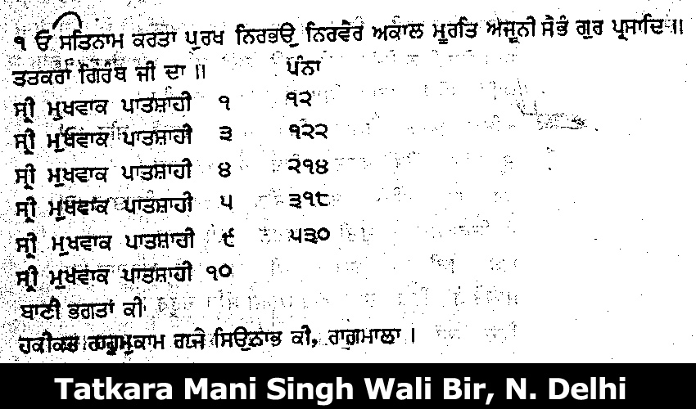

- The first portion of the Granth, which is Ad Granth or Guru Granth Sahib which is bounded together in this Bir. The academic analysis shows that this is the Banno version of Guru Granth Sahib and not the Damdami version. Banis of Gurus consistent with Banno version including apocrypical Shabads of Guru Nanak (Jit Dar Lakh Mohamada, Bhai Atash Aab.), Mira Bai shabad, Ratan Mala, and Ink recipe (How can you associate this Bir with Mani Singh who compiled and wrote Damadami bir in 1706. Then why would he write the Banno version? Therefore on academic basis, this bir cannot be related to Bhai Mani Singh. Rather it will be disgraceful to label that this bir first part which is Guru Granth Sahib banno version, was written by Bhai Mani Singh in 1713 ).
- One of Alam Kavi’s Dohra attributed to 10th Guru.
- This bir ends at Hikiats as mentioned by Giani Gian Singh. Zafarnama is written in Persion.Then who wrote it in Punjabi in differet Granths?
- The textual analysis of the Bhai Mani Singh Bir clearly shows that the Chhand count of this bir is different from the presently published Dasam Granth. For example Ram Avtar in this bir has 860 Saloks, but in the presently published Dasam Granth there are 864. Krishan Avtar Saloks are 2447 in this Granth while in the present granth there are 2492 in number. Charitro Pakhyan has 7560 saloks in this bir while presently published granth has 7555 saloks. There is no Swayee 33, Shabad Hazarey, and Khalsa Mehma in this bir. But all these three compositions are in the presently published bir since 1902 (compiled by Sodhak Committee in 1895 to 1896). How then one can explain this corruption of this great Granth based on evidence?

B. Patna Bir Academic Issues

I have also gone over the Patna Bir, you mentioned. There are two old Patna birs of Dasam Granth which are of academic significance, but my summary regarding them is as follows:

- No colophon available.
- Tatkara shows the date written as 1775 (1698 CE) but Zafarnama written in the end in same hand puts date to at least 1706 academically. Patna Bir contains 7 compositions by P10 which were deleted by the Sodhak Committee, Sukhmana Sansaharnama, Var Malkauns, Var Bhagoti, Rag Sorth by P10, Rag Asal P10, Asfotak Kabits and one bir contains 18 chapters of Bhagwant Gita.

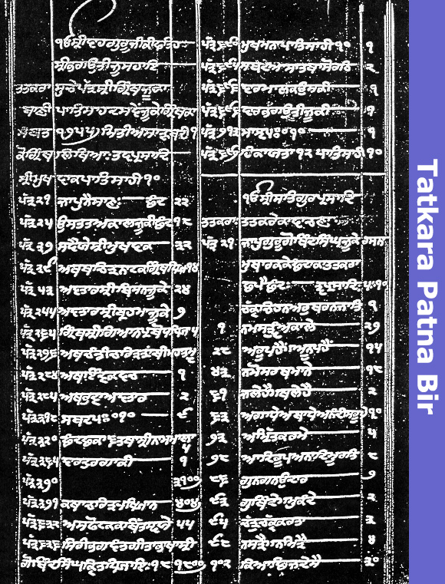

Please Note the open folio of the Tatkara says that Tatkara Granth Ju Ka (wr1tten in samat 1755 which is 1698 CE) Your Email mentions it was written in 1720 CE?. It does not mention anywhere on the open folio Sri Bichitar Granth as reported by you. I differ with you that none have dared to corrupt any portion of this great Granth. But if you evaluate this Granth then it is very clear academically that the following 7 compositions present in this granth were deleted by the Sodhak Committee in 1895-1896 and they are not presently published Dasam Granth. Who has the authority to delete or corrupt any portion of this great Granth? “Sukhmana Sansaharnama, Var Malkauns, Var Bhagoti, Rag Sorth by P10, Rag Asal P10, Asfotak Kabits and one bir contains 18 chapters of Bhagwant Gita”.
How then one can explain, this corruption of this great Granth based on evidence?

TEXTUAL ANALYSIS OF DIFFERENT DASAM GRANTH BIRS. Clearly shows the arrangment difference and chhand count difference in various dasam Grath Manuscripts as outlined above.

C) DG Hazoori /or anandpuri bir Academic issues
- Contains two paintings of 10th guru in possession of Matasundri pasted on page 1 and 14.
- Four different kinds of pages, no folio numbers on Khas Patras
- Five different scribes, Darbari Singh, Darbari Singh Chhota, Nihala, Bala and Haridas.
- History goes up to Maharaja Ranjit Singh times as taken from a Granthi employed by him.
- At two places dates of 1752 BK (1695 CE) come in wrong chronological order (Chandi Ukat Bilas on page 125 written in fagun 1752 but Jodh Parband written on page 154 on chet 1752). On folio 109, 116 dates - 1745BK and then 1744BK also wrong chronology
- Probably this bir is the same as the presidium bir used by Sodhak Committee in 1897 with two pictures, scribe, described as Darbari Singh Wadha, and Darbari Singh Chhota. Ankpali rewritten at some pages, some of the pages new. Total pages 403. History goes back to Jit Singh Granthi employed by Maharaja Ranjit Singh.
- Padam in 1990 writes about new evidence of painting of 10th guru while hunting as strong evidence to support his contention about authenticity but no history of such photographs is available. Internal evidence only takes it to the period of Maharaja Ranjit Singh.

D) Devnagri Dasam Granth

Are you aware of this Devnagri Dasam granth prepared by Britishers in 1847 after Sikhs lost ist Anglo sikh war in 1946 and British became masters of Panjab Virtually.
MSS Panjabi D6 bears a note from the Commissioner, “In conformity to the orders of the Governor General of India this volume named ‘The Grunth Sahib’ published by Gooroo Gobind Singh the founder of the Sikh faith, is hereby presented to the Paris Exhibition Society by Pundit Radha Kishum, Ecclesiastical Councellor to His Highness the late Maharajah Runjeet Singh”. This manuscript is in Devnagri and starts with Om. The table of contents starts with Om Sat Sri Suchi Panjabi Granth Sahib Ka Sri Mukhbak Patshahi 10.
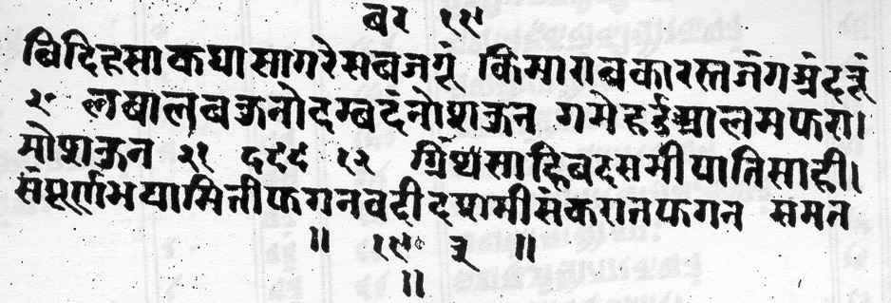

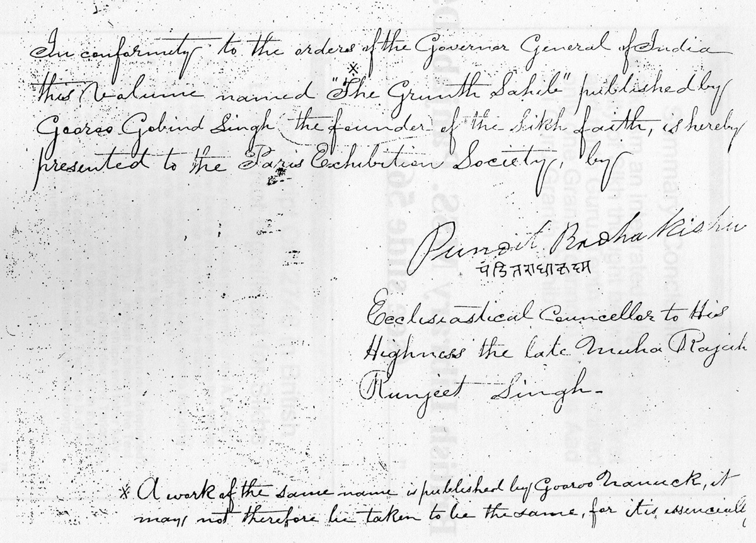
WHY Governor General of India has to give official orders to publish this volume in devnagri in 1847?(after Sikhs lost First Anglo sikh War in 1846 and Britsh becam virtual masters of Punjab in 1847 throuh Regency council headed by Treachrous Teja Singh)

I have gone over this issue in depth for last several years and presented my findings at Punjabi Uni . and GNDU in Dec.2003. Summary of my paper is as follows.

Guru Granth Sahib as the only Sikh Canon; Fresh Look at the Text and History of Dasam Granth
Summary
By Jasbir Singh Mann

Personal Guruship was ended by the 10th Guru after finalizing the Sikh mission and sanctifying and passing succession to Guru Granth Sahib as a future Guru of the Sikhs in 1708. This was the final culmination of the Sikh concept of Guruship, capable of resisting the temptation to defy the lines of human Gurus. The Tenth Guru while maintaining the concept of Shabad Guru also made the Panth distinctive by introducing corporate Guruship. The concept of Guruship continued and the role of human gurus transferred to the Guru Panth and that of the revealed world to Guru Granth Sahib making Sikhism a distinct modern religion in 1708. This historical fact is well documented in Sikh sources of 18th century. Sainapat (1711), Bhai Nandlal, Bhai Prahlad, and Chaupa Singh, Koer Singh (1751), Kesar Singh Chibbar (1769), Mahima Prakash (1775), Munshi Sant Singh on account of Bedi family of the Una, Unpublished records, Bhatt Vahis. Persian sources: Mirza Muhammed (1705-1719 AD), Sayad Muhammed Qasim (1722 AD), Hussain Lahauri (1731), Royal Court News of Mughals, Akhbarat-i-Darbar-i-Mualla (1708). Western accounts of 18th century including Father Wendel, Charles Wilkins, Crauford, James Browne, George Forester, and John Griffith clearly emphasize the tenants of Nanak as enshrined in Guru Granth Sahib as the only promulgated scripture of the Sikhs.
There was no Dasam Granth found in Punjab or Delhi area in 18th century. There is no evidence that in 18th century”Adi granth was not given any exclusive preference over the bani of Guru Gobind Singh” as this idea was floated by Mcleod & Grewal J.S. Malcom’selfcreated story ”at time of Khalsa Initiation ,Five weapons were presented to the intiate” which is further promoted by Pashaura singh & Mcleod “ Orgnizers of Singh Sabha Movement replaced the tradition of Five Weapons with that Of Five religion symbols(known as Five Ks)” is not Based on any Sikh or western Source. There were 32 Dasam Granths circulating in the Amritsar’ area by 1890. The presently published Dasam Granth (1902) was created by the Sodhak Committee formed of British Cronies (1895-1897) to give a closer to the Granth floated by them in the late 18th century with the help of Nirmalas at Patna. The manuscript of this granth was implanted in the East India Library by Colebrook & Charles Wilkins and used by John Malcom in 1810, in his book “Sketch of the Sikhs”. Devnagri Dasam Granth (Presently in British Library, London) was written in February 1847 after the Sikhs lost the first Anglo-Sikh War (Second treaty with Lahore December 16, 1846 at Bhairowal when Britishers became virtual masters of Punjab). Treacherous Sardar Tej Singh was the chief of the regency council when this Devnagri Dasam Granth was created. In recognition of his services, the title of Raja was conferred on him on August 7, 1847. Story of Mani Singh compiling a Dasam Granth between 1721 to 1738 during his stay at Amritsar at the request of Mata Sundri is difficult to prove by evidence as the Dasam Granth reported to be compiled by him was found only in 1818 and the first part of this manuscript is a Bano Version of Guru Granth Sahib which makes it very unlikely to be the composition compiled by Mani Singh who compiled the Damdami version earlier. The story of Mehtab Singh and Sukha Singh slaying Massa Ranghar and reward of successful mission keeping the various parts of Dasam Granth as a single volume cannot be supported by any historical evidence. Babadeep Singh is said to have compiled another manuscript of Dasam Granth in 1747 A.D. as reported by Giani Singh which ends at Asfotak Kabit. Only Sangrur Bir as studied by Padam & Jaggi Is reported to end with final title Asfotak Kabit .Therefore, probably it is the same Manuscript as reported by Giani Gian Singh . The first portion Of This Manuscript is Guru Granth Sahib & 2nd portion is Dasam granth.This Manuscript Contains additional compositions Like Sansahar Sukhmana, Vaar Malkauns and Chakka Bhagoti Which Were edited & deleted by Sodhak Committee in 1897, therefore cannot make this manuscript authentic. By history Babadeep Singh bir/Sangrur bir appeared in 1857 only. The author has reviewed the history and text of Dasam Granth from 18th to 20th century and the summary of the findings is as follows:
• Historical analysis shows that 10th master may have made many Granths noted in the literature e.g. Smudsagar / Avtarlila / Vidyasagar Granth/Vidyadar Granth / Bachitar Natak /Satsai Granth. But no original Granth is available as they were lost in river and warfare.
• Bhai Mani Singh is reported to compile Dasam Granth between 1721-1738 at request of Mata Sundri but no original available.Photgrphs as published by Dr. Padam In His 3rd Edition reported to be in possession of Mata sundry Has no Histry of 18th&19th century.
• Controversy of Dasam Granth Authenticity started in 18th century and still continues
• By the end of 19th century (1895), 32 birs of Dasam Granth were in circle in Amritsar which were used by Sodhak Committee to finalize the final version of Dasam Patshahi GURU Granth Sahib sahib JI.
• . Lahore Singh Sabha With 118 associations DID NOT Recognize This new Dasam Pathshai Guru Granth Sahib in 1897. 3 articles published in Khalsa Akhbar Lahore against this committee on october 4th,25th&november 1st 1895.
• 1897 - Above bir has no significance among the Sikhs as not mentioned by Akali Ran Singh, 1905 in his book about Dasam Granth
• Kahan Singh Nabha in 1930 in Mahan Kosh does not mention 1897 sodhak Committee report or dasam granth published in 1902 based on this report. He talks about only two birs of Mani Singh & Sukha Singh Bir& requests more thorough work on this issue.
• Dharam Pal Ashta 1959 Based his Thesis On Sodhak committee Report of 1897 without confirming Authenticity of Dasam Granth Manusripts he used in his study.
• Historical analysis shows that no bir of Dasam Granth was seen in Punjab or New Delhi area ia 18th century, only Charles Wilkins in 1781 sees some second Granth in Patna which he reported appeared later and also reported that Guru Granth Sahib was the only sanctified and promulgated.
• Historical records show, Banda Singh, Nawab Kapur Singh, Jassa Singh Ahluwalia, and Sikh Misals of the 18th century do not revere Dasam Granth. Baghel Singh built 8 hitorical Gurudwaras in New Delhi in 1784 and no evidence of Dasam Granth installed anywhere.
• Textual analysis of all known birs of Dasam Granth show variations of titles in Tatkara, variation of titles at start of composition and variation of contents. History of no DG birs goes before 1818.
• No original Khas patra available. Letter of Mani Singh is spurious
• Historical inconsistencies in Bachitar Natak. There are various scribes of Dasam Granth. Difficult to discuss orthography as no original is available.
• Ideological inconsistencies and ideological variations
• Heterogeneous Granth of different collections compiled by Sukha Singh and promoted by the British
• Dating inconsistencies. Wrong chronology, 7 compositions excluded in 1897 published Text ?
• Bachitar Natak, a manipulative collection with no mention of martyrdom of 5th Guru. Reverence of Adi Granth compiled in 1604 and as spiritual guru to the Sikhs since then. No mention of creation of Khalsa and Amrit ceremony.
• Malcom’s sketch of the Sikhs created a distorted Sikhism to diminish the spirit of the Sikhs and their government as proposed by William Franklin in 1803 in his account.
• 10th guru only gave sanctification to A.G.G.S. alone in 1708 and not to any other Granth
• Bani of A.G.G.S. is the sole Guru for Sikhs and a sole canon to accept any idea, concept, suggestion, and any writing
• Based upon above doctrine Banis / writing of 10th Guru accepted in Sikh Rahat Maryada got Sanctfied By Guru Panth (1927-1936) are final and unquestionable. Japu Sahib, 10 swaeyas(swarg Sudu Waley 21-30 akal ustit) Chaupai, Ardas (as sanctioned RehatMaryada).including Akal Ustit (except Chhand 201-230),khalsa mehma, 33 Swaeyas, Shabad Hazarey and Zafarnama are banis / writings of 10th Guru. Khalsa Panth collectively is allowed to make / accept any changes based upon the doctrines as established in A.G.G.S. acceptable to the Guru Panth

In my opinion review of history and texts of various dasam Granth manuscripts and literature proves that"Presently published Dasam Granth since 1902 is a piece of Sikh literature like many other books in Sikh history. Evidence shows that it is a compilation of heterogeneous granths in late 18th century by Mahant Nawal & Dayal Singh and Sukha Singh Granthi at Patna by converting a Hindoove language manuscript “Nanak Panthi Kabya” to Gurmukhi Granth, Dasmi Patshahi Granth presently located in Brtish Library(MSS Panjabi D5 donated to the library by HT Colebrooke). They interpolated Bani and writings of Patshahi 10 and other simialar saloks like GGS to gain credibility of this Granth which was promoted by Malcom initially in “Sketch of the Sikhs” published in 1810,1812. Brought to Punjab Gurdwaras by Nirmalas in early 19th Century.Sikhism is an integrated religion with unity of Sikh thought between the first and tenth Guru. Tenth Guru sanctified only one Granth (cannon), which is Sri Guru Granth Sahib.

Compostions of 10th guru as accepted by the Panth(per SRM) are final and unquestionable and can not be challeged by anybody. Japu Sahib, 10 swaeyas(swarg Sudu Waley 21-30 akal ustit)and kabio Benti Chaupai upto end of hymn' Dust dokh tay loh Bachai" as writings of 10th Guru (as sanctioned RehatMaryada). In my opinion Authenticity of any document must be established by all academic Parameters before accepting it. Time has come Central Sikh authorities must revisit this issue in Light of more academic evidence presently available on this presently published dasam Granth since1902( based on sodhak commite report 1895-1897)

For OPINION ON autheticity issues of Dasam Granth BY OTHER SCHOLARS. Please Click onhttp://www.globalsikhstudies.net/r_link/dasam.htm

For debates on Skh study issues.Click on www.Globalsikhstudies.net

Jasbir singh mann M.D.
California

